Welcome to

This is “Britannias Cobberdogs” Puppy Application Form

All at “Britannias” are health tested. Do browse through all pages on our web site which we hope you will find welcoming – informative and user friendly.
Details required for the Change of Ownership registration form
Information not be shared
Name:- First__________________________
Surname ___________________________
Home Address

Post Code ________________ Country __________________

Home Phone + code if outside UK:- _______________Mobile Phone:- ___________________
Email:- _________________________________________

Do you have any family members a doctor or specialist has diagnosed with allergies or asthma:- ___________
Do you have family members a Doctor or specialist has stated are allergic to dogs: - _____________

Male Pup: - ______________
Female Pup: - ______________
No preference: - ______________

Size:-
Miniature: - _______
Medium:-_________
No Preference:- _______

Colour:_
Do you have a colour preference:- ______________
No Colour preference:- _______________________
Would you be happy to choose a pup regardless of sex or colour:- _______________

Do you have a dog proof garden: - _______________

Litters due:-
Would you like to reserve a pup:- _______

Where did you hear about us:-
Web site:- _________________
Face Book Web Page:- _______
Friend:- ______
Other:- ______
Please stipulate:- ___________________________________________

Forward completed Puppy Application form to:-

Email:- Suzziq381@aol.com

Website:- https://www.britanniascobberdogs.com/

Follow us on Facebook:- https://www.facebook.com/Britannias-Australian-Cobberdogs-UK-349590462072876/?fref=ts

I look forward to hearing from you and hope you have enjoyed your time on my site
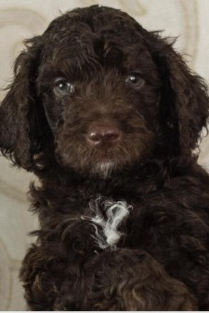

Suzzi Breeder of UK

